Forest School Association Annual Report, December 28th 2017

2016/17 has seen many of the ambitions of the Forest School Association come to fruition, as we roll out those schemes that have long been in development. We have tested these schemes in the wider community and it has been a year of reflection as we look at what the values of the Forest School community are, and how we, as the professional body can reflect those values and encourage the increase in standards. It has also been a year of change for the FSA as our founding chair Jon Cree stepped down and Lily Horseman took on the role.

In this year we undertook a review of the function of the FSA which has helped to shape our decisions and priorities. An overview of the work of the FSA in 2016/17 is included here.

Training Quality Assurance Scheme
This was one of the goals that the FSA was set up to achieve and to have the scheme launched this year has been a testament to the work put in by the FSA working group and a wider consultation group with the support of FSA staff and an external project worker – Nell Seal. The FSA working group consists of Louise Ambrose, Jon Cree and Lily Horseman. We have also had the support of Chris Millett, a previous director of the FSA, who has had experience of working on the IOL professional accreditation schemes.

The scheme concluded the pilot phase during 2017, resulting in 2 Trainers gaining FSA Registration and a further 5 going on to gain full FSA Endorsement. The first endorsed trainer and registered trainer who were not involved with the pilot phase are now also on the map. To administer the scheme, we have retained the services of Nell Seal as an external project worker. The pilot phase of the scheme included a consultation of members to discover what they value about Forest School training, which provided us with a valuable insight into the training experience. This consultation received the most feedback of any consultation by the FSA published to date.

Stage 1 of the process asks for all the experience and qualifications (both validated), policies and procedures, course schedules, evidence of guided learning hours and how trainees are supported through the training process.
Stage 2 involves interviews with newly qualified trainees. The first 5 endorsed trainers act as assessors for this stage.
Stage 3 involves interviews with the trainers. The panel for these interviews consists of two of the first 5 of the endorsed trainers who act as an assessor alongside Nell Seal.

The QA process will continue with training events to maintain trainers’ own CPD and up to date training practice in Forest School. The FSA aim to cover the expenses associated with the scheme and have invested considerable time and energy to bring it to this point. It does not bring any income into the FSA as it is important that we make it as accessible as we can. This scheme is now open to the Forest School training community.

Forest School Qualification review
In late 2015 OFQUAL, the government regulatory body for qualifications, introduced a new qualification framework – the Regulated Qualification Framework. This meant that all qualifications that are to be recognized by government needed to be reviewed by the end of 2017. The FSA, with the support of the Forest School Trainers Network (GBFSTN), have worked closely with Open College West Midlands Region to complete this review.

This involved:

- Extensive email consultation with all members of the GBFSTN
- Collation of responses from many members of the GBFSTN
- A meeting of West Midlands network members
- 1 day in London with SE network members
- 3 days of meetings in Oxford with agreed working group including Open College Network West Midlands
- 32 skype meetings between working group members, each lasting up to 4 hours
- Communication with other Awarding Organisations.

The final documents were produced by a core working group comprising Clair Hobson, Sarah Lawful, Lily Horseman, Jon Cree, and Linda McDonnell. Following another round of consultation with members of the GBFSTN the new qualifications were approved and have been added to the RQF.

The FSA would like to thank the GBFSTN and the working group for their time and effort in conducting this review. Particular thanks go to Clair Hobson for steering this work through to completion.

How have the qualifications changed?

The qualifications are still worth the same number of units (e.g. Level 3 is still worth 18 units).
- The revised qualifications place more emphasis on the Forest School principles.
- They make the relationship between woodland, people and wellbeing much clearer.
- The transition between level 2, for Forest School Assistants and level 3, for Forest School Leaders is easier.
- They include guidance and indicative content for trainers.

The FSA have continued to work with awarding organisations to ensure they know about the new units and are adopting the qualification guide which provides some minimum standards by which awarding bodies should be establishing Forest School training centers. These were developed, with the FSA and GB Trainers Network when the qualifications were put on to the previous national Qualification Credit Framework. There are now 7 awarding bodies who have adopted these standards.

Organisational Membership

The FSA Recognised Forest School Provider Scheme was 'soft launched' earlier this year and officially launched In October.

While this is a membership scheme, the FSA sees this as being a way for organisations to demonstrate that they are at least attempting to work towards embracing all the six principles and are part of the wider Forest School community. We calculate that there is a 76% success rate for applicants. We expect this to improve as the scheme matures. Although we are only assessing that providers meet the 6 principles of Forest School, the application is a significant undertaking that requires the provider to have all the essential elements of Forest School in place. No one has yet managed to get straight through the process without us needing to ask for further information, or evidence, about their provision. These may be straightforward matters but sometimes applicants find that they need to make some significant changes to their practice and provision. Feedback from successful candidates is often that they have found the process to be an excellent opportunity to reflect on their practice and provision and to make any necessary adjustments.
All applicants now have an opportunity to discuss their application with the Development Officer before submitting it.
Since the soft launch and the 19th December 63 notifications to apply have been received.
- Of these, 37 have gone on to submit their applications.
- Of the 37, we are still processing 8 (waiting for additional information).
- 22 have been approved
- 5 have not supplied the required evidence
- 2 providers have chosen to withdraw.

Lisa Pierce, the FSA development Officer has continued to shape and refine the process. A consultation with members at the conference and online helped clarify the Forest School principle that relates to the long term aspect of Forest School.

Membership and Membership Services

The number of members has steadily grown in the last year – the current membership is at 1925, compared with 1682 in late October 2015
This breaks down into;
1464 Individual Members,
430 Trainee Members,
22 Forest School Recognised Providers,
3 Registered Forest School Trainers,
6 Endorsed Forest School Trainers

The Newsletter has been produced quarterly and circulated to members as well as more than 70 news items on the website.

The website had a full overhaul and is easier to navigate and is much more user friendly. Guidance notes added this year have included Ofsted registration and Principle 1- the long term nature of Forest School. The feedback for the website has been very positive and it is proving to be a valuable resource.
The website gets an average of 1.24k hits per day on the website (this is an increase on 2016)
11,600 likes on Facebook
5,800 Twitter followers
We deal with an average of around 40-50 enquiries per week.
A new and growing LinkedIn forest school community of over 700 contacts and a re-activated Forest School UK LinkedIn group of 158 has been recently established.

Insurance
We have continued to promote deals on insurance for members and work with insurance companies to put out a consistent message about appropriate levels of cover for Forest School.

Union Membership
We now have a memorandum of understanding between the FSA and Unison. If this proves achievable and fruitful we envisage that, in the long term, our members will be able to enjoy the same benefits of union membership that the members of Unison have access to.
The FSA will not be a part of the union, but we will be a ‘recognised’ body.

DBS
We are in the process of negotiating a discounted DBS service with an existing umbrella body details of this will be launched to members in the new year.

Other membership services We continue to seek discounts for our members

with various companies and for particular products

Conference 2017

The July conference was another milestone event in the development of Forest School in the UK. The theme this time was ‘well-being in the woods’. It took on a slightly new flavor with one short keynote on the importance of well-being, stating some stark UK statistics on young people’s well-being and the role contact with nature has in increasing well-being. 180 practitioners were present, some with families, looking at the role movement and music has in well being, indeed there were a number workshops making beautiful music and rhythms emanating from the woods surrounding Glyndwyr University, near Wrexham. Other workshops included working with special needs, autism, the role of story, contributions to diet and ways of adding spice and creativity to our food at Forest school. The partnership with our hosts, Plas Dewr Forest School, made this a very relaxing yet stimulating event, pushing forward the agenda for the role of Forest School can have in the well being of the nation. See the following sections of the FSA website for more details and useful information; http://mailchi.mp/f05864ee9a16/the-word-from-the-woods-summer-2017?e=7906339c58 and http://www.forestschoolassociation.org/?s=Conference+2017
Work has begun on the 2018 conference which will be held in Norfolk.

Local groups
We now have 20 groups listed on the website, 10 of which are now constituted and formally affiliated to FSA, the most recent being FSA Suffolk. Each group organizes itself in a different way and runs their own events, skill shares and CPD sessions. Each local group elects a national representative to represent them on a working group which meets 4 times a year via skype to share practice, discuss common issues and work together on projects. These representatives are able to communicate with each other and with the national FSA via Basecamp (on-line project management software that is being extended to each of the local groups to help with their own membership management and organization). This year the group has identified common issues that local groups encounter and plan to work together on resources that may be useful for groups in the future.

National and International Advocacy

Membership of national groups has continued including;
- The Council for Learning Outside the Classroom School Grounds National Sector group and the Natural Environment Sector group. Both these groups continue to make representations to government agencies. In the last year the focus has been on research, basing advocacy on strengthening the research into the value of outdoor learning. In an extensive RSPB piece of research published in Summer 2017, Forest School was highlighted as one of the key programmes being used in the primary sector for nature education.
- Forestry Learning and Working Development Group changed its name to the Forest Skills Forum – this group has continued to work on the woodland/forestry trailblazer apprenticeship scheme, one of the first new apprenticeship schemes to be started in the UK. Also this year saw the group help steer a new Forest Skills study in England looking at the state of the sector and how education in the primary and secondary sectors could support more people entering the sector, see http://www.rfs.org.uk/media/442086/forestry-sector-skills-study-executive-summary-2017.pdf
- The FSA continues to be on the steering group for the Forest Education Network

The FSA made a submission in early December, based on dialogue with membership and the wider FS community, to the latest UK government consultation on changes to the Offensive Weapons Act. This mainly focused on the knife legislation, including the purchasing and transportation of knives.

The FSA have been approached by the HMI of the DfE to work together on how Forest school can support work with Special Educational and Mental Health needs.

The FSA is a partner organization for the Charter for Trees, Woods and People which was launched on November 6th 2017 in Lincoln castle. The Tree Charter is rooted in more than 60,000 ‘tree stories’ gathered from people of all backgrounds across the UK, including many involved in Forest School see https://treecharter.uk/ .

We continue to be approached by other countries and still providing links to Forest School Canada, Finland, South Korea, China and Turkey. More recently the FSA has been approached by organisations in USA for support and advice on how to develop FS in a number of states in the US. Significantly the Irish Forest School Association (IFSA) was launched in May 2017, see https://irishforestschoolassociation.ie/ . Jon Cree, FSA director, made a keynote at the conference and a number of English trainers supported the launch conference, running workshops through the weekend. The FSA continues to support the IFSA in its early stages of development.

Finances
The majority of funding for the FSA comes from membership and the conference – see the annual accounts at the end of this annual report. With this in mind we are looking to the new organizational membership to ensure continued financial stability and growth.

Staffing and Governance

Staffing
Gareth Davies is our acting CEO and as ever has worked hard answering the many enquiries received that aren't the routine ones the FSA office deals with. He also advises the directors on strategic directions as well as working with a number of national and regional organisations and local FSA groups. Gareth continues to do valuable work on the services provided for members through the website and works closely with the office. His workload increased from 2 days a week to 4 during the development and launch of the new schemes and with the overhaul of the website but is currently working 3 days per week.

We have also employed a part time development officer, Lisa Pearce. She currently works 2 days a week and her particular remit is the FSA Recognised Forest School Provider scheme as well as conference organization.

We have also been fortunate to contract the services of Nell Seal who has shaped and refined the Trainers QA scheme and has pushed forward to make sure the scheme is of the highest quality.

We have continued the fruitful relationship with the Institute for Outdoor Learning, who we contract for the routine administration of the FSA. A particular thanks go to Dave Brookes who has done a fine job both answering enquiries, updating the website and working on the member newsletter.

Board of Directors
The Board of Directors considers itself to be a working board. The increase in staffing in 2017 has meant that there has not been the same level of requirement for the board to fulfil functions and this has allowed time for more long term development.
Directors of the FSA have both operational and strategic responsibilities – given our budgetary and operational capabilities. The board meets monthly to fulfill these responsibilities. There are a number of working groups which all directors contribute to.
Jon Cree stepped down as chair this year however he remains an active part of the board. Lily Horseman moved from Deputy Chair to Chair with Sara Collins taking on the role of Deputy Chair. Jon has been a tireless champion of the FSA and of Forest School. It is in part a testament to his vision that things have developed so far since the start of the FSA in 2012.

As Chair, I would like to take this opportunity to thank all the directors for the hard work they have carried out in 2016/7. Their commitment to Forest School, it’s growth and quality is second to none - from working with the charity commission and companies house through to producing material for the website; keeping members and the FS community up to date through social media; securing member services and benefits; supporting local groups; reviewing and writing policies; work on the 2017 and 2018 conference planning; the organizational membership scheme; trainers QA scheme and forging the way forward for the organization.

I would like to thank, in particular, Elly Dolan for her contribution as director over the last 3 years. She is stepping down at the next election due to work commitments, her contribution to the strategy and governance of the FSA has been particularly welcome. Darren Lewis also stepped down earlier in the year as he found himself unable to commit to role of director.
Finally, a MASSIVE THANKS again to Chris Millett, who, despite stepping down as a director has supported the trainers QA scheme through the pilot phase and has taken an active role in interviews and feedback.

We look forward to this year's elections – there are 4 people standing, including myself and Sara Collins (we stood down having been directors now for 3 years since our last election) we look forward to having new directors on board to renew energy and involvement in 2018. The FSA met with the candidates for directorship in 2016 and 2017 and has been more rigorous in checking they are fully aware of the responsibilities of FSA directors and subsequently put them forward to stand for election. This is a significant change to previous years where members had to base their voting on limited information provided by the candidates themselves.

The next year offers lots to celebrate. The Forest School movement in the UK will be 25 years old next year, we have plans in place for a national conference in October and we look forward to seeing our schemes move from strength to strength.

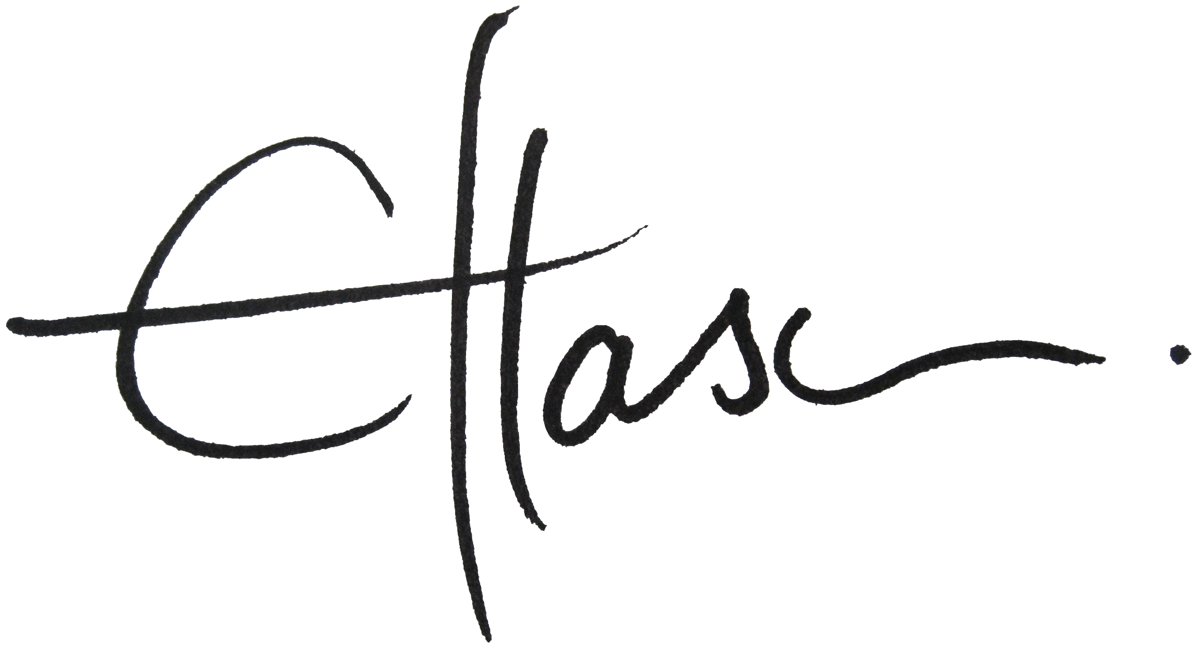

Lily Horseman – FSA Chair - on behalf of the FSA board;

Sara Collins – deputy chair
Geoff Mason – Secretary

Jon Cree - Treasurer
Louise Ambrose
Sara Collins
Jo Philips
Kathryn Barton
Elly Dolan

Forest School Association – Draft Summary of Accounts Year ended 31.8.17

31.8.17 31.8.16

£ £
Turnover
Memberships 49515 36579
Conferences 17932 24600
67477 61179
Other income
Sundry receipts 3376 -
Deposit account interest 3 1
3379 1
70826 61180

Expenditure
Rent* 2,900 1,800
Insurance 267 261
Wages* 43,046 15,813
Pensions 681 -
Subcontractors** 7,951 905
Telephone and website 1,037 559
Advertising 421 -
Travelling 361 -
Administration fees 8,855 5,314
Meeting and conference expenses 15,590 23,209
Sundry expenses 100 -
Accountancy 655 634
81,503 48,856
(10,677) 12,324

Finance costs
Bank charges 1,057 768

NET (DEFICIT)/SURPLUS (11,734) 11,556

TOTAL ASSETS LESS LIABILITIES 16,629 28,363

*Average Employees for 2017 was 2 & for 2016 was 0.4
**Project management for the establishment of the FSA Trainers Quality Assurance and Organisational Membership schemes.

